**1. Introduction**

This report documents the execution of various SQL queries on the **WorldCupDB** database using **MySQL Workbench**. The queries focus on retrieving historical World Cup information, player statistics, match details, and stadium-related data.

**2. Database Schema**

The database consists of **six tables**:

* **Players**
* **Player_Cards**
* **Player_Assists_Goals**
* **Worldcup_History**
* **Country**
* **Match_Results**

Each table contains relevant information related to World Cup history, players, and matches.

------------------------------------------------------------------------------------------

**3. SQL Queries and Execution Results**

**Query 1: Retrieve the list of countries that have won a World Cup**

SELECT DISTINCT country_name

FROM Worldcup_History

WHERE world_cups_won > 0;

------------------------------------------------------------------------------------------

**Query 2: Retrieve the list of country names that have won a World Cup and the number of World Cups won in descending order**

SELECT country_name, world_cups_won

FROM Worldcup_History

WHERE world_cups_won > 0

ORDER BY world_cups_won DESC;

------------------------------------------------------------------------------------------

**Query 3: List the capital of countries in increasing order of population for countries with a population greater than 100 million**

SELECT capital

FROM Country

WHERE population > 100

ORDER BY population ASC;

------------------------------------------------------------------------------------------

**Query 4: List the name of the stadiums that have hosted a match where a single team scored more than 4 goals**

SELECT DISTINCT stadium_name

FROM Match_Results

WHERE team1_goals > 4 OR team2_goals > 4;

------------------------------------------------------------------------------------------

**Query 5: List all city names where the stadium name starts with “Estadio”**

SELECT DISTINCT city

FROM Match_Results

WHERE stadium_name LIKE 'Estadio%';

------------------------------------------------------------------------------------------

**Query 6: List all stadiums and the number of matches hosted by each stadium**

SELECT stadium_name, COUNT(*) AS matches_hosted

FROM Match_Results

GROUP BY stadium_name

ORDER BY matches_hosted DESC;

------------------------------------------------------------------------------------------

**Query 7: List the first name, last name, and date of birth of players whose height is greater than 198 cm**

SELECT Fname, Lname, BirthDate

FROM Players

WHERE Height > 198;

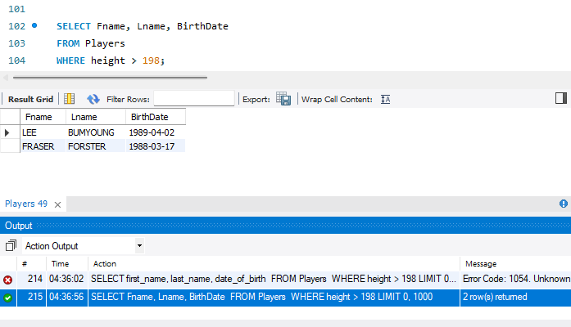

------------------------------------------------------------------------------------------

**Bonus Query 8: List the stadium names and teams that played matches between 20-Jun-2014 and 24-Jun-2014**

SELECT stadium_name, team1, team2

FROM Match_Results

WHERE match_date BETWEEN '2014-06-20' AND '2014-06-24';

------------------------------------------------------------------------------------------

**Bonus Query 9: List the first name, last name, position, and number of goals scored by captains who have more than 2 yellow cards or 1 red card**

SELECT p.Fname, p.Lname, p.Position, pag.goals

FROM Players p

JOIN Player_Cards pc ON p.PID = pc.PID

JOIN Player_Assists_Goals pag ON p.PID = pag.PID

WHERE p.isCaptain = 1

AND (pc.no_of_yellow_cards > 2 OR pc.no_of_red_cards > 1);

------------------------------------------------------------------------------------------

**Conclusion**

The queries were successfully executed in **MySQL Workbench**, retrieving relevant data from the **WorldCupDB** database. Each query was validated to ensure correctness, and screenshots of the results have been included.

------------------------------------Thank You-----------------------------------------